Challenge-Based Learning (CBL)

Presenter: Meri Johnson, Science Coach, CEEMS Grant at UC
Co-Presenters: David Vernot, consultant, Butler County ESC, UC CEEMS, and Ohio Dept of Education; Kristen Keish, Teacher of AP Calculus and Dual Enrollment Precalculus, Statistics, and College Algebra, Goshen High School
Date: Thursday, June 16, 2016
Time: 1-4 PM
Venue: University of Cincinnati, Zimmer Hall, room 414

Prepared by:
John J. D’Alessandro, St. Xavier High School, Cincinnati, Ohio
RET Participants for Project #2: “Synthesis Characterization of Graphene for Energy Storage Devices.”

The session was presented by Meri Johnson, who currently serves as a science coach for the CEEMS grant at UC as well as a science consultant and trainer for other organizations. She earned a BA in Biology at Miami University and a Masters in Secondary Education from Northern Kentucky University. She was the science consultant for Clermont County Educational Service Center from 2002-2012. Meri is a National Board Certified Teacher in Adolescence and Young Adulthood Science. She also taught high school sciences for twenty years. There was assistance David Vernot, consultant, Butler County ESC, UC CEEMS, and Ohio Department of Education; and Kristen Keish, Teacher of AP Calculus and Dual Enrollment Pre-calculus, Statistics, and College Algebra, Goshen High School. It was held on Thursday, June 16, 2016 from 1PM – 4PM at the University of Cincinnati in Zimmer Hall in Room 414. Before the session began, participants were seated in small groups by discipline.

Ms. Debora Liberi introduced the presenters and informed participants that Cohort 4 CEEMS teachers would be aiding in the workshop. Ms. Johnson started the presentation by listing objectives: Define Challenge Based Learning (CBL) and Develop an understanding of the components of CBL. She announced that participants will work, practicing brainstorming ideas for each component and drafting their own plan.

CBL was presented as a process to connect academic content to students’ world, provide a way for them to take ownership of their own learning and thinking, and to develop critical life skills.

This led to a video of work from Ms. Keish’s classroom being presented as an example of using CBL to engage students. There was a lead-in to brainstorming from the use of statistics applied to weather. There was a review of the previous day’s information about hard work leading to success even when natural ability is lacking. They had had a speaker in on artificial intelligence. There was then discussion of the speaker’s presentation and leading from simpler to more complex developments. This brought the conversation back to weather. Ms. Keish tied the topic to the students’ families and farms. She had them list concepts and industries that are affected by or related to weather. The students decided to look at statistics tied to agriculture dealing with weather. Then, she led them to brainstorm about how weather may affect agriculture. She wrote on the board the elements that students presented. She helped them flesh out some ideas with each other for clarity.
To prepare for the group discussion, she had them brainstorm in small groups about essential questions related to weather affecting agriculture. She gave an example from another topic. The students in the video proceeded to work on developing questions. They wrote on their desks using dry erase markers. Then, Ms. Keish brought the class’s attention to the front of the room and solicited information from the students. She proceeded to write some of the questions on the board. She then guided them to attempt to refine and combine ideas down to one essential question. The students settled on “When is the best time to plant crops?” The students were informed that they would do a challenge based on the essential question. Ms. Keish had them brainstorm on paper a challenge they wanted to do, turn in slips, and she told them she’d review them that evening.

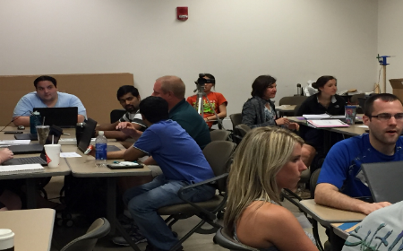
After the video, Ms. Johnson wanted the discipline groups to discuss what they saw Ms. Keish doing in the video. The participants discussed the activities that Ms. Keish performed for about three minutes, and then Ms. Johnson brought the attention of the room together and asked for comments from the room. There is a challenge to having students develop their own questions. There is giving of ownership to the students, but with guidance from Ms. Keish. She had them brainstorm. There was accountability both by having the students photograph their work and turning in the slip at the end of class.
Figure 1. Participants Commenting on Ms. Keish's Presentation

Ms. Johnson turned the room over to Mr. Vernot. He pointed out that every teacher will be slightly different and that the participants should feel normal if they feel discomfort at the ease with which Ms. Keish guided the students. The CBL process was presented and it was pointed out that it is before the engineering design process. He pointed out that participants will need to assure that the essential question can support the Academic Content Standards they need to cover. An example was presented from a physics classroom and cell phone drop safety. Another example was on changing cereal boxes for packaging and sales. Another example on school air pollution was presented. Participants were asked to discuss how the flow from Big Idea through Essential Question to Challenge may look, and how they understand it better or if they need questions answered. They did this in small groups for about five minutes. Mr. Vernot asked for any “ahas!” or questions.
- The “Big Idea” does not necessarily come directly from the standards. It can be incredibly creative.
- Do you start with standards or “Big Idea” in planning process?
  - Ms. Keish gave an example of related rates… so it started with standard, but she wanted the class to make rain barrels. So, Big Idea backwards. However, the statistics example was planned the opposite way.
  - Ms. Johnson said that regularly happens either way.
  - Mr. Vernot said you can be inspired in many places and regularly people find a neat idea and can then make it fit their standards.

Ms. Johnson closed the sharing and recommended that the whole group start to get to work. She asked for ways to engage students with a “Big Hook” and then gave an example from a video of the Mars One’s human mission to Mars. An example of a hook could be showing a video. Suggested standards were photosynthesis, use of water, migrating populations.
In small groups, participants discussed other hooks. After about three minutes, participants shared.
- Current events
- Field trip
- Demonstration or Observation
- Sports
- Random items to engage them
- Survey
- Mini-challenge

Ms. Keish then refocused on the “Big Idea.” The Mars One intro was actually on a lesson on “Sustainability.” Participants were challenged for other “Big Ideas.” The participants were all able to come to at least one other Big Idea.
“Essential Questions” come after “Big Idea,” so participants were challenged to brainstorm on paper some essential questions for sustainability. Participants were given poster-sized Post-It notes. Participants were directed by Ms. Johnson to place ONE essential question on the Poster. As participants posted their choice, they were directed to think about sub-questions that could be used to suss out more information to address their question. Ms. Keish pointed out that all 6 groups could have different questions. Each group read their question. No question was identical to any other. From the essential questions, Ms. Keish posited, the Challenge can be created to address their question, the Big Idea, and the standards.
Participants were given 5 minutes to generate some challenges based on their question. Discipline teams posted one of the challenges on their posters.
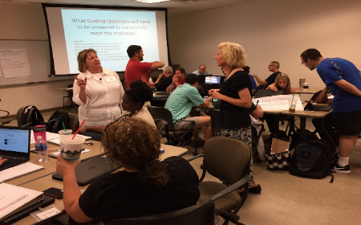
Ms. Keish explained that guiding questions help guide students to help them meet their challenge. Examples were given based off of a photosynthesis challenge. Participants challenged to brainstorm on how to help students differentiate essential questions (broad, about “what I want to do”) and guiding questions (more narrow, about “how do I accomplish that task”). Participants were also challenged on how to honor all student-generated questions. Participants offered writing all of them down, allowing all to be researched, and simply acknowledging the questions as valid.
Figure 2. Participants Brainstorming
Participants were instructed to come up with guiding questions to go with their challenge. There were many discussions about how difficult and how many questions should be created.
After receiving a CBL Planning Worksheet, people seemed to understand the point. Participants were asked to look at other discipline groups’ posters.

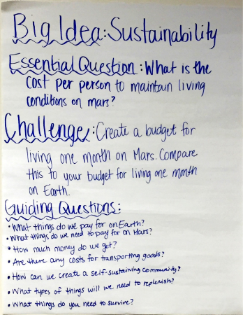
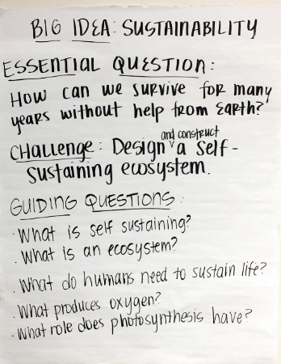
Figure 3. Example of Poster Made by Discipline
Participants were instructed by Mr. Vernot that guiding questions can be conceptual, theoretical, or very practical.
Ms. Johnson instructed that the next step is planning the lessons.

Figure 4. Another Different Example with Same Big Idea

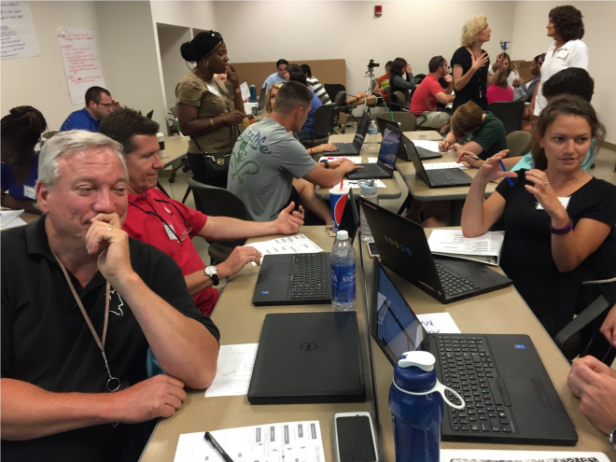
So teams were challenged to find which Academic Standards are being covered or to brainstorm “Big Ideas” for next year’s Unit. Also, they were instructed to use the planning worksheet to begin their own draft.

Participants were instructed to “take 5 big steps.” They were paired with their closest person and were to discuss their project development. They were, again, instructed to take 5 big steps and then discuss with their new partner “next steps.”

The participants were asked to fill in evaluations and then dismissed.

Figure 5. Participants Working in Pairs

